**Design Header**

Grid Based Levels

**Sub-Features**

World Select

In this area, you name and/or link to any other designs which are specifically linked to this one. For a Weapon design document, you may have other sub-designs like:

• Player inventory management

• Weapon ranges

• Aim assist

• Ammo pickups

• etc

**Essence Statement/Logline**

Escalating levels with gradually increasing levels of entry and exit.

What’s the vision of this gameplay design?

**The Player's Story**

The player will take command of their own army and strategize and attack the defending enemy’s territory.

Here you can provide a short blurb detailing a moment in gameplay where this design comes into play. “The player picks up the Weapon, holds the right trigger and a projectile streaks forward, knocking an enemy pawn into the ground”. This is the area where you can let loose a bit with story elements that support the gameplay design.

**Titles with Similar Elements**

If there are other games that have a similar gameplay design, list them here.

**Anti-Vision**

The player will not be able to place towers on paths

The attacking army will not go off path

The player will not be selecting the level they want to play

If there are games out there that have similar elements but don’t do what you do, make it clear here. For weapons, you could say that:

• This game is not about collecting and selecting 80 different kinds of weapons. We have just one gun.

• By concentrating the alt-fire features on a specific type, we keep our weapon animation budget in check, save on memory in multiplayer, and play to our strengths.

**Reference Material**

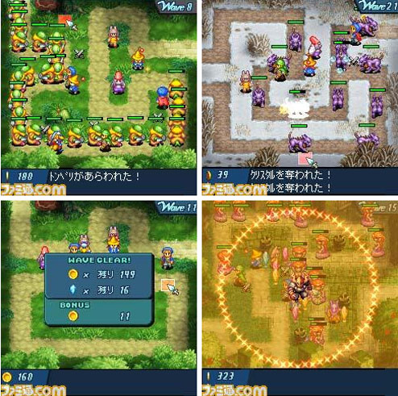

Ideal Level Templates:

Early Levels:

Start to finish (A-B)  
 One object to block line of sight

Secondary Levels:

Start to finish with one fork in the road

Two large objects to block line of sight

Tertiary Levels:

Start to finish with two starts and one fork

Two large objects to block line of sight

Final Levels:

Start to finish with two starts, two forks and two finish points

Two large objects to block line of sight

If you have pictures that support your gameplay design, drop a couple in here. You should limit the width of the pic to no more than 800 pixels – trust me, co-workers who have their monitors on a lower resolution will thank you.

**Controls**

Place a jpeg of the control scheme here. Nothing fancy, just a picture of the Sixaxis/360 pad/mouse/keyboard with notes detailing what aspect of the design is controlled by what input mechanism. Text with arrows pointing to buttons, that’s what we want to see.

**Objectives and Requirements - MINIMUM**

* **The attacker must get from point a (start) to point b (finish)**
* **If the attacker reaches point b they must now plan their defense (with tower placement)**

Here’s where you earn your pay. Break down the gameplay design into its basest element – if the publisher walked into your studio tomorrow and said, “You’re shipping in one week”, what is the core part of your design that absolutely has to make it into the game? List those details here. Remember, you’re trying to ensure that the Lead Designer doesn’t cut your design entirely, so make it easy for him/her by pointing out where reductions can be made without losing the essence of the design. For example:

• Weapon will have a fully automatic primary firing rate.

• Pressing Right on the d-pad will select the weapon.

• Ammo information will be displayed on the HUD.

• Weapon will be replenished by touching an ammo box.

That’s it. It’s basic as hell, but it can mean the difference between having part of your design getting into the finished game, and having it cut completely. Do yourself and the team a favour.

**Design Behaviour: What the Player Sees and Hears**

Planning

* See the map
* They order their army
* Player observes

Defending

* See the map
* Players place their towers
* Player observes

Break it down from the player’s perspective. When they do “X” with the gameplay design, they see and hear this. Using the Weapon example:

**Primary Fire**

Behaviour

• Holding the **Primary Fire** button triggers **Fully Automatic** fire from the Weapon.

• Holding the **Zoom** trigger brings the player's POV into ironsights mode.

**What the Player Sees**

• Muzzle flash

• Tracers

• Appropriate impact FX (environment/opponent)

• HUD ammunition counter decrease

• Red reticule if enemy targeted within range

• White reticule if no enemy targeted within range

• Blue reticule icon change if friendly targeted

Primary Reload

• Player raises weapon

• Player pulls ammo clip from weapon with left hand to offscreen

• Player slams new ammo clip into weapon

• Player racks weapon with left hand

• Weapon ready state

**What the Player Hears**

• Weapon firing

• Environmental/opponent impact FX

• Dry-fire clicking when out of ammo

• Primary Reload

• Ammo clip unhooking and removal

• Ammo clip entry and clicking into place

• Racking weapon SFX

**FX**

• Muzzle FX

• Tracers

• Impact FX -environment

• Impact FX -opponent

• Blood FX -opponent

**HUD**

• Reticule

• Ammo indicator -Primary

**AUDIO**

• Audio primary fire

• Audio primary fire impact

• Enemy pain audio for primary fireimpact

**Rough Estimates**

**Engineering**

This is a prioritized list of engineering tasks to complete the Minimum phase. You’ll need to submit your design to the Lead Engineer since a rough estimate is needed and is expected to be refined and updated once the feature is broken down into system oriented tasks. Confidence is your percentage of confidence that you can hit a date based on your estimate. As you don’t have access to a Lead Engineer ☺ don’t worry about this section.

**Content**

This is a prioritized list of content required to complete the Minimum phase. The Lead Artist needs to vet your design since a rough estimate is needed and is expected to be refined and updated once the feature is broken down into system oriented tasks. Confidence is your percentage of confidence that you can hit a date based on your estimate. As you’re not working with a Lead Artist, skip this section also.

**Design**

This is a prioritized list of content required to complete the Minimum phase. The Lead Designer will vet your design since a rough estimate is needed and is expected to be refined and updated once the feature is broken down into system oriented tasks. Confidence is your percentage of confidence that you can hit a date based on your estimate. You’re the lead designer, so you’re responsible for prioritizing implementation and listing it here. A good producer can help you with this.

**Objectives and Requirements - SHIPPING**

Now, take what you have for the minimum and throw it out. Detail what you want to see for the shipping version of the game, ie. You have enough time to implement and tune the design within a reasonable development schedule. You don’t have to regurgitate everything from the Minimum section of the Design doc, but you do need to expand and detail what the Shipping version of the design will be, based on all of the parameters above.

**Objectives and Requirements - STRETCH**

OK, now if someone came up to you at the end of development and said, “Hey! You’ve got another 6 months to work on this design!” – what pie in the sky stuff can you horseshoe in? This is your money-is-no-object wishlist section, segmented in the same way as the Minimum and Shipping sections.